Course Registration & Enrollment System
Web Engineering (CSC-324) – Assignment 3
Instructor: Syed Nouman Ali Shah
Submission Date: November 15, 2025
Student Name: Saad Mugha;
Roll Number: F2023-009
Program: BS Computer Science
Semester: 5

Executive Summary
This report documents the development of a comprehensive Course Registration and Enrollment System built using Spring Boot for the backend and React for the frontend. The system implements a complete domain model for managing students, courses, and registrations with robust business rule validation and RESTful API architecture.
Technology Stack:
Spring Boot 3.x Spring Data JPA MySQL Database React 18 React Router Axios RESTful APIs

Part 1: Domain Model & JPA Entities

1.1 Entity Design & Relationships
The system implements three core entities with proper JPA mappings and bidirectional relationships:

Student Entity
Attribute | Type | Constraints
id | Long | Primary Key, Auto-generated
rollNo | String | Unique, Not Null
name | String | Not Null
email | String | Unique, Valid Email Format
program | String | Not Null (e.g., BSCS, BSE)
semester | Integer | Min: 1, Max: 8

Course Entity
Attribute | Type | Constraints
id | Long | Primary Key, Auto-generated
code | String | Unique, Not Null (e.g., CSC-324)
title | String | Not Null
creditHours | Integer | Min: 1, Max: 6
maxSeats | Integer | Min: 1
prerequisite | Course | Self-reference (Optional)

Registration Entity
Attribute | Type | Constraints
id | Long | Primary Key, Auto-generated
student | Student | Many-to-One, Not Null
course | Course | Many-to-One, Not Null
semester | String | Not Null (e.g., Fall 2025)
status | Enum | REGISTERED, COMPLETED, DROPPED
grade | String | Optional (A, A-, B+, etc.)
registrationDate | LocalDate | Auto-set on creation

1.2 JPA Annotations & Validations
Key JPA annotations implemented:
- @Entity - Marks classes as JPA entities
- @Id & @GeneratedValue - Primary key with auto-increment strategy
- @ManyToOne & @OneToMany - Bidirectional relationships
- @JoinColumn - Foreign key column definitions
- @NotNull, @NotBlank - Bean validation
- @Email - Email format validation
- @Min, @Max - Numeric range validation
- @Enumerated - Enum type mapping for status

1.3 Repository Layer
Custom query methods implemented in repositories:
// StudentRepository Optional<Student> findByRollNo(String rollNo);
// CourseRepository Optional<Course> findByCode(String code);
// RegistrationRepository List<Registration> findByStudentId(Long studentId);
List<Registration> findByCourseId(Long courseId);
List<Registration> findBySemester(String semester);
List<Registration> findByStudentIdAndStatus(Long studentId, RegistrationStatus status);

1.4 Sample Data Seeding
A DataLoader component seeds the database with initial data on application startup:
- 5 Students with diverse programs (BSCS, BSE, BSDS)
- 5 Courses with prerequisite relationships (CSC-201 → CSC-324)
- 5 Sample registrations with different statuses
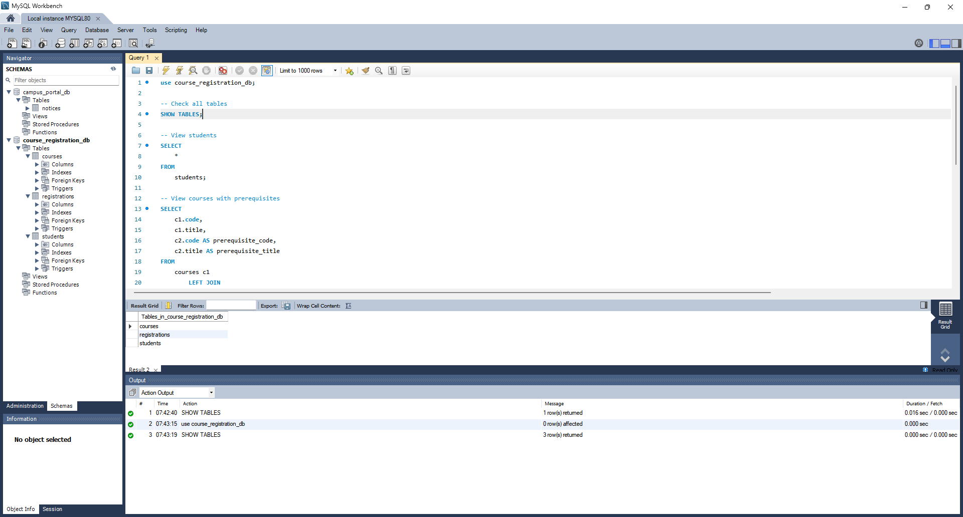

Part 2: RESTful API Design & Business Rules

2.1 Student API Endpoints
Method | Endpoint | Description | Status Code
GET | /api/students | Retrieve all students | 200 OK
GET | /api/students/{id} | Get single student by ID | 200 OK / 404 Not Found
POST | /api/students | Create new student | 201 Created
PUT | /api/students/{id} | Update existing student | 200 OK
DELETE | /api/students/{id} | Delete student | 204 No Content
GET | /api/students/{id}/registrations | Get student's registrations | 200 OK

2.2 Course API Endpoints
Method | Endpoint | Description | Status Code
GET | /api/courses | Retrieve all courses | 200 OK
GET | /api/courses/{id} | Get single course by ID | 200 OK / 404 Not Found
POST | /api/courses | Create new course | 201 Created
PUT | /api/courses/{id} | Update existing course | 200 OK
DELETE | /api/courses/{id} | Delete course | 204 No Content
GET | /api/courses/{id}/registrations | Get course registrations | 200 OK

2.3 Registration API Endpoints
Method | Endpoint | Description | Status Code
POST | /api/registrations | Register student for course | 201 Created / 400 Bad Request
GET | /api/registrations | Get all registrations | 200 OK
GET | /api/registrations/{id} | Get registration by ID | 200 OK / 404 Not Found
PATCH | /api/registrations/{id} | Update registration status/grade | 200 OK
DELETE | /api/registrations/{id} | Delete registration | 204 No Content

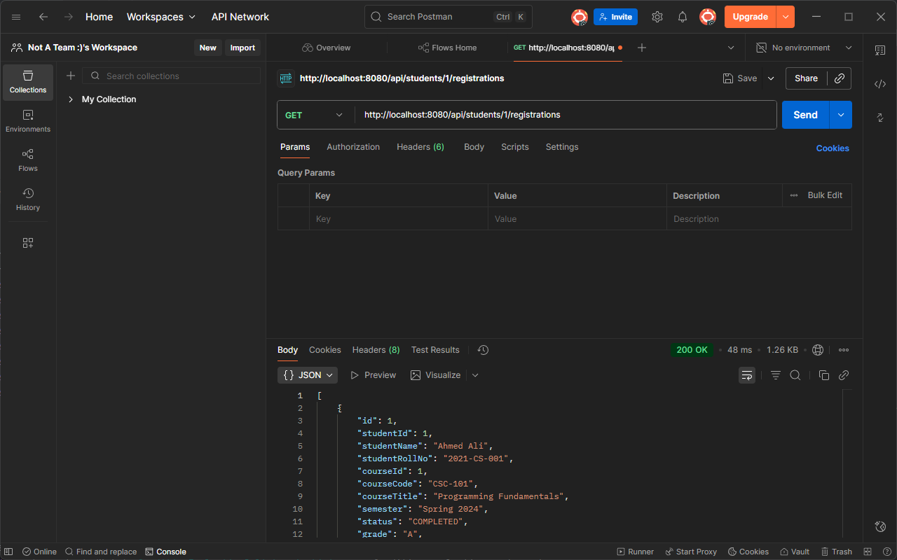

2.4 Business Rules Implementation
The system enforces three critical business rules in the RegistrationService layer:

Rule 1: Maximum Course Limit
A student cannot register for more than 5 active courses (status = REGISTERED) in the same semester.
Implementation: Query count of active registrations before allowing new registration.
if (activeRegistrations >= 5)
{ throw new BusinessRuleViolationException( "Student cannot register for more than 5 courses in the same semester" ); }

Rule 2: Maximum Seat Capacity
A course cannot exceed its maximum seat capacity for a given semester.
Implementation: Count current registrations and compare with maxSeats.
if (currentEnrollment >= course.getMaxSeats())
{ throw new BusinessRuleViolationException( "Course has reached maximum capacity" ); }

Rule 3: Prerequisite Validation
If a course has a prerequisite, the student must have completed it (status = COMPLETED) before registering.
Implementation: Check for completed prerequisite registration.
if (course.getPrerequisite() != null)
{ boolean hasCompleted = registrationRepository.existsByStudentAndCourseAndStatus( student, course.getPrerequisite(), RegistrationStatus.COMPLETED );

if (!hasCompleted)
{ throw new BusinessRuleViolationException( "Student must complete prerequisite: " + course.getPrerequisite().getCode() ); } }

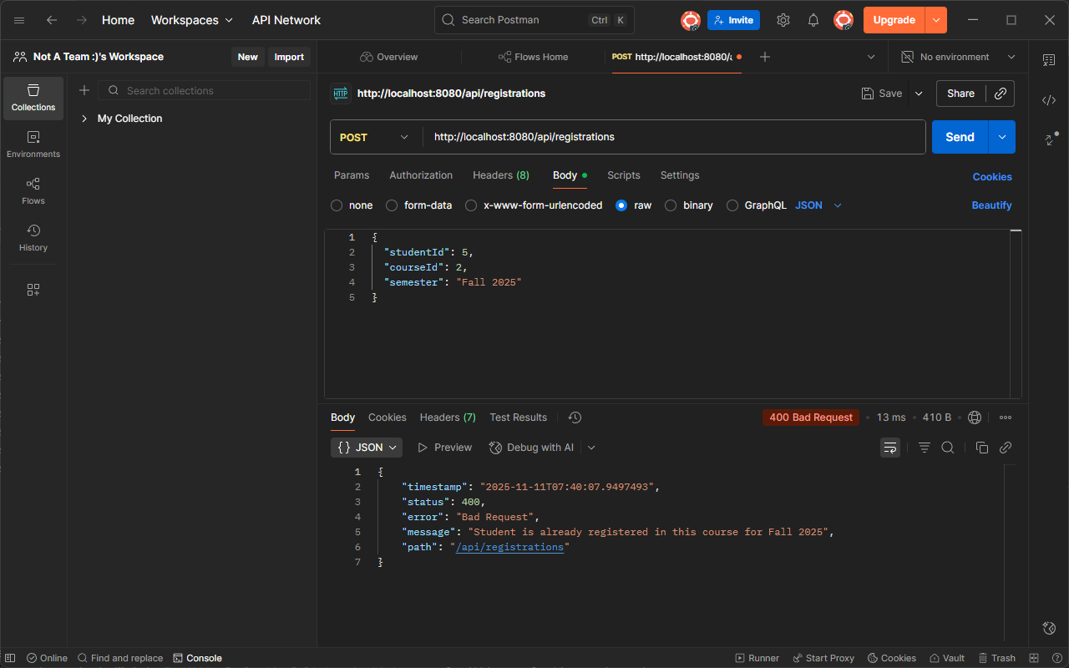

2.5 Exception Handling Architecture
Custom exceptions with @RestControllerAdvice for centralized error handling:
- StudentNotFoundException - Returns 404 with error message
- CourseNotFoundException - Returns 404 with error message
- RegistrationNotFoundException - Returns 404 with error message
- BusinessRuleViolationException - Returns 400 with violation details
All exceptions return consistent JSON format:
{ "timestamp": "2025-11-11T10:30:00", "status": 400, "error": "Bad Request", "message": "Student cannot register for more than 5 courses", "path": "/api/registrations" }

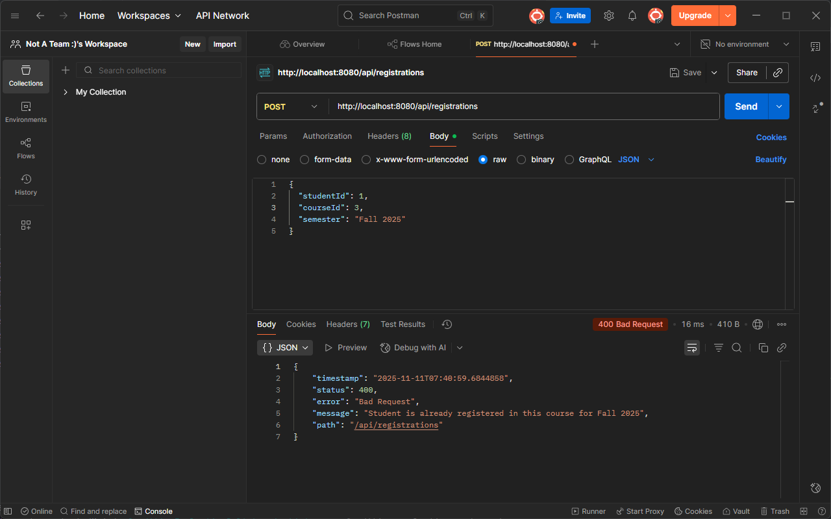

Part 3: React Frontend Implementation

3.1 Application Architecture
The React frontend follows a component-based architecture with clean separation of concerns:
Component | Responsibility | Key Features
App.js | Main application shell | Routing, navigation, layout structure
CourseList.js | Display available courses | Search, filter, registration trigger
RegistrationForm.js | Course registration modal | Student selection, semester choice, submission
StudentDashboard.js | Student registration view | Student selection, status filter, data table
api/api.js | API integration layer | Axios configuration, endpoint definitions

3.2 Course Listing & Search Feature
The CourseList component provides:
- Fetches all courses from GET /api/courses on component mount
- Real-time search filtering by course code or title
- Category-based filtering (Design, Business, Languages)
- Responsive card-based layout with hover effects
- Displays course details: code, title, credits, max seats, prerequisites
- Visual prerequisite warnings with highlighted badges
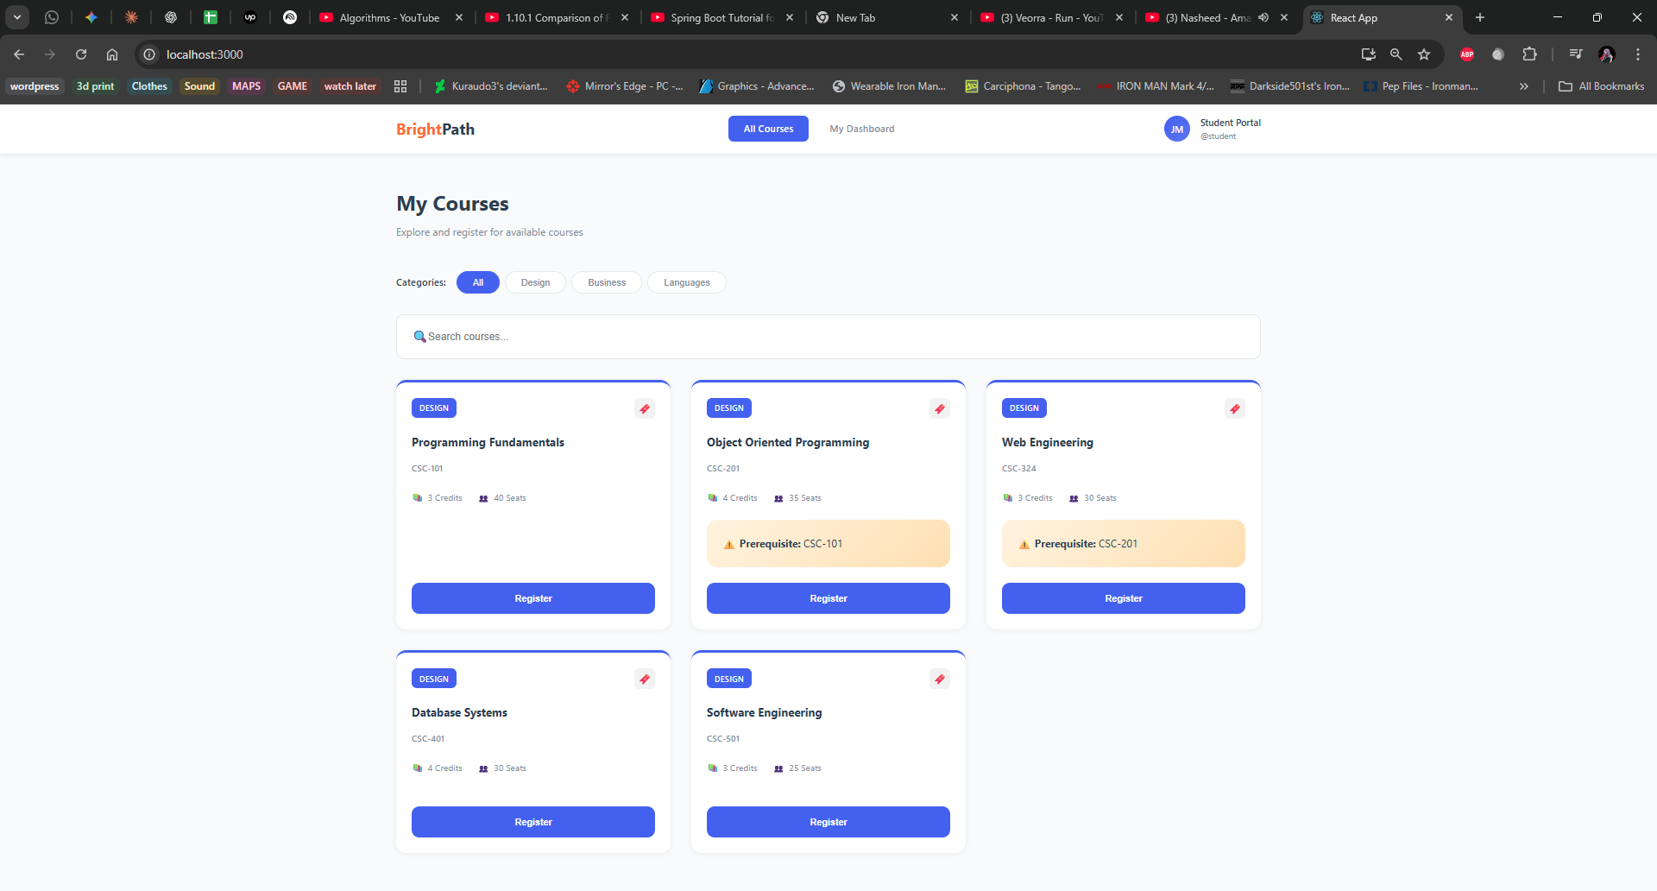

3.3 Registration Form & Modal
The RegistrationForm component implements:
- Modal overlay with course information display
- Student dropdown populated from GET /api/students
- Semester selection dropdown (Fall/Spring/Summer)
- Form validation before submission
- POST request to /api/registrations with proper error handling
- Success alerts with green notification
- Error alerts showing business rule violations
- Loading state during API call with disabled submit button
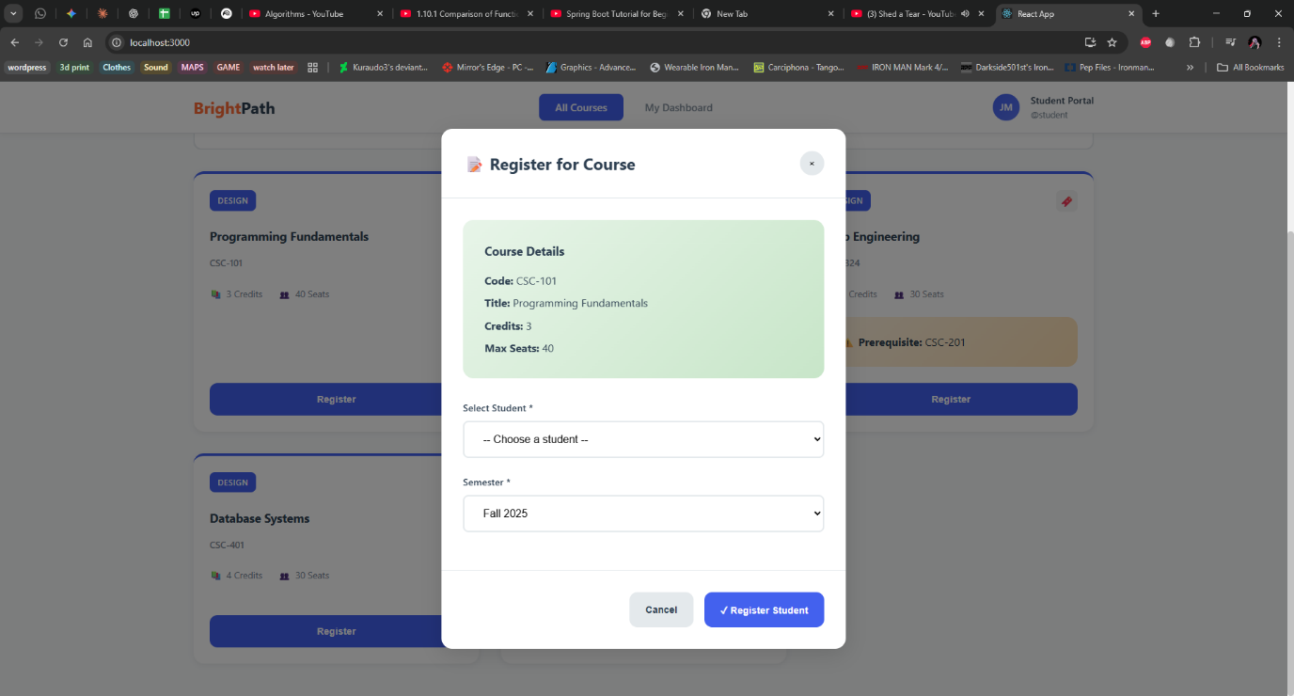

✓ Successful Registration Flow
When registration succeeds, the system:
- Displays success alert: "✓ Registration successful!"
- Closes the modal automatically
- Refreshes the course list to update available seats
- Auto-dismisses alert after 5 seconds
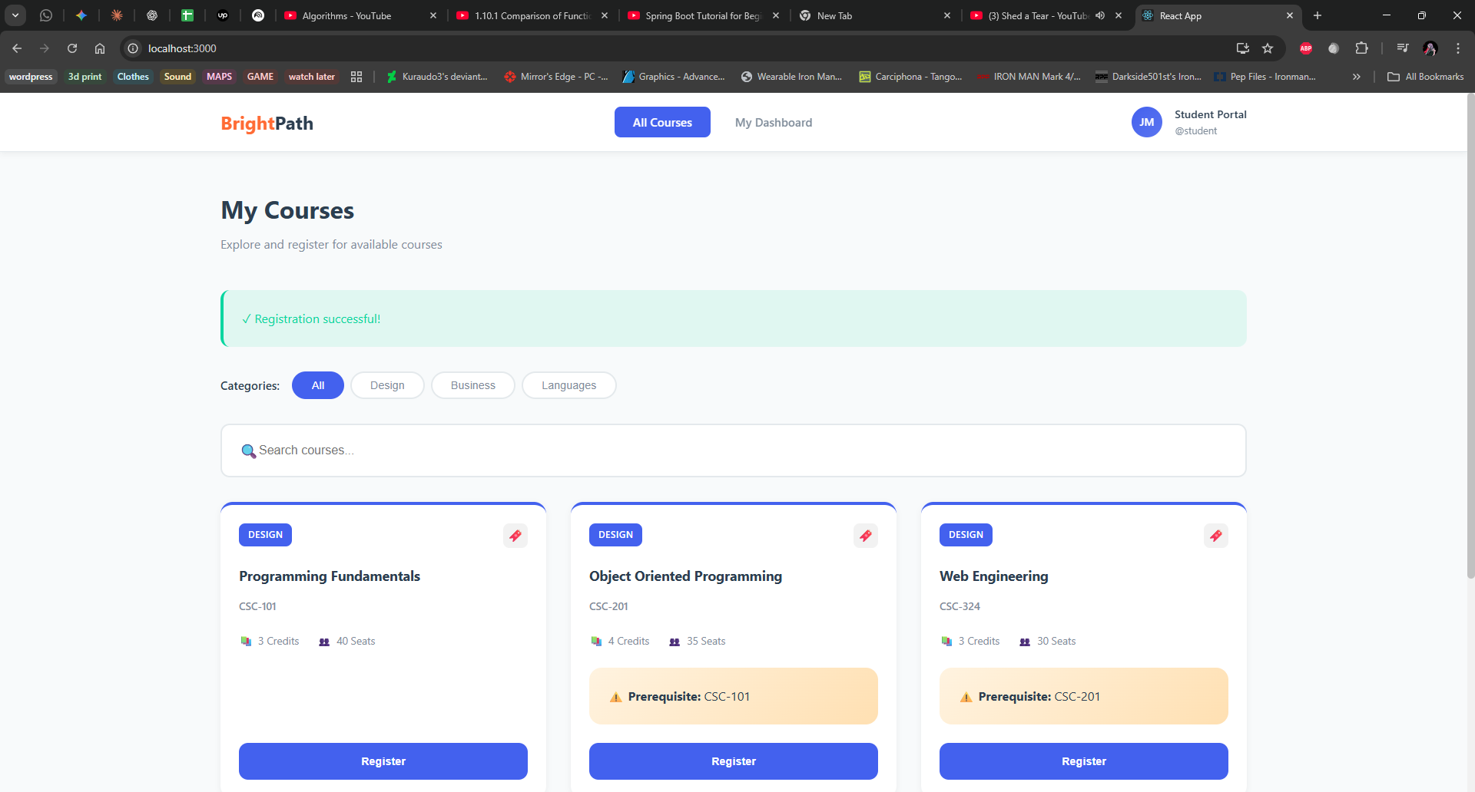

⚠ Error Handling Example
When business rules are violated:
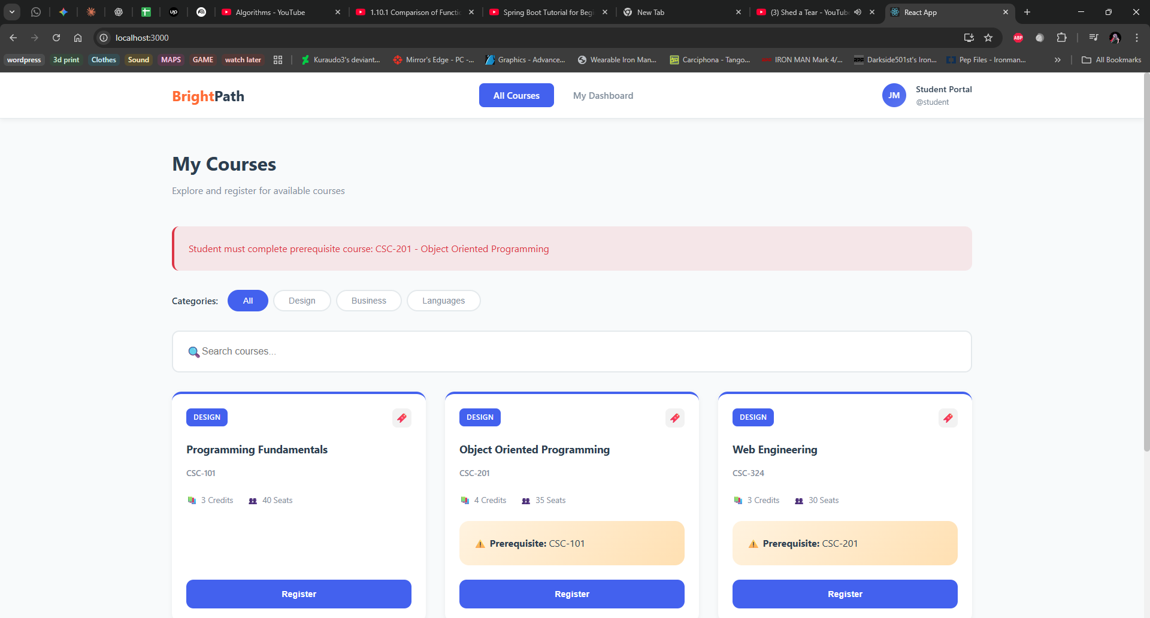

3.4 Student Dashboard
The StudentDashboard component provides comprehensive student view:

Features:
- Student dropdown for selection
- Displays complete student information (name, roll no, email, program, semester)
- Statistics cards showing counts: Registered, Completed, Dropped courses
- Status filter to view specific registration types
- Data table with sortable columns: Course Code, Title, Semester, Status, Grade, Date
- Color-coded status badges (Blue: Registered, Green: Completed, Red: Dropped)
- Empty state message when no student is selected
- Loading indicators during data fetch
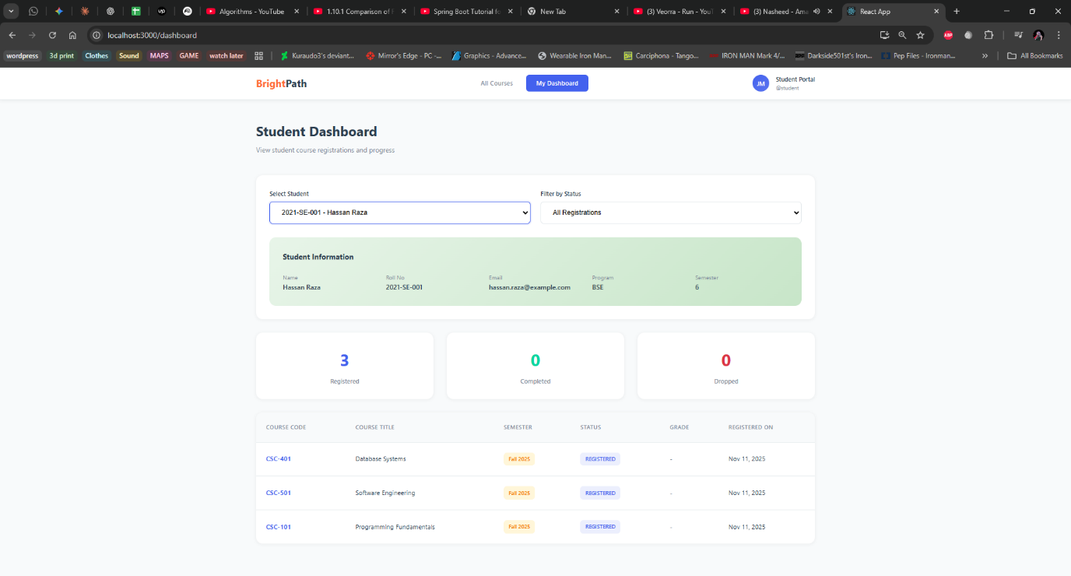

3.5 UI/UX Design Highlights
The interface incorporates modern design principles:
Aspect | Implementation
Color Scheme | Primary Blue (#4361EE), Accent Orange (#FF6B35), Success Green (#06D6A0)
Typography | System font stack with proper hierarchy and readable sizes
Spacing | Consistent spacing system using CSS variables (--space-sm, --space-md, etc.)
Components | Cards with subtle shadows, rounded corners, hover effects
Responsiveness | Mobile-first grid layouts, adaptive navigation
Accessibility | Semantic HTML, proper labels, keyboard navigation support

Testing & Validation

4.1 Backend API Testing (Postman)
All endpoints were thoroughly tested using Postman:
Test Case | Expected Result | Status
GET /api/students | Returns all 5 students with 200 OK | ✓ Pass
GET /api/courses | Returns all 5 courses with prerequisites | ✓ Pass
POST /api/registrations (valid) | Creates registration, returns 201 | ✓ Pass
POST /api/registrations (duplicate) | Returns 400 with error message | ✓ Pass
POST /api/registrations (no prerequisite) | Returns 400 "Must complete prerequisite" | ✓ Pass
POST /api/registrations (max courses exceeded) | Returns 400 "Cannot register more than 5" | ✓ Pass
POST /api/registrations (course full) | Returns 400 "Course at maximum capacity" | ✓ Pass
GET /api/students/{id}/registrations | Returns student's registrations | ✓ Pass
PATCH /api/registrations/{id} | Updates status/grade, returns 200 | ✓ Pass
DELETE /api/registrations/{id} | Deletes registration, returns 204 | ✓ Pass

4.2 Frontend Integration Testing
End-to-end testing scenarios verified:

Scenario 1: Successful Course Registration
- Navigate to Course List page
- Click "Register" on a course
- Select student from dropdown
- Choose semester
- Click "Register Student"
- Result: Success message displayed, modal closes

Scenario 2: Prerequisite Validation
- Attempt to register a student in CSC-324 (Web Engineering)
- Student has NOT completed CSC-201 (Data Structures)
- Result: Error message "Student must complete prerequisite: CSC-201"

Scenario 3: Maximum Course Limit
- Student already registered in 5 active courses
- Attempt to register for 6th course
- Result: Error message "Cannot register for more than 5 courses"

Scenario 4: Student Dashboard Navigation
- Click "My Dashboard" in navigation
- Select student from dropdown
- Student info and statistics display
- Registrations table populates with data
- Apply status filter (e.g., "COMPLETED")
- Result: Table filters to show only completed courses

4.3 Cross-Browser Compatibility
Browser | Version | Status
Google Chrome | 120+ | ✓ Fully Compatible
Mozilla Firefox | 121+ | ✓ Fully Compatible
Microsoft Edge | 120+ | ✓ Fully Compatible
Safari | 17+ | ✓ Fully Compatible

Technical Implementation Details

5.1 Project Structure

Backend Structure:
course-registration-frontend/
├── public/
├── src/
│ ├── api/
│ │ └── api.js # Centralized API calls
│ ├── components/
│ │ ├── CourseList.js # Displays list of available courses with filters
│ │ ├── RegistrationForm.js # Modal/form for course registration
│ │ └── StudentDashboard.js # Displays registered courses for the student
│ ├── App.js # Main app file handling routes
│ ├── App.css # Global styles
│ └── index.js # Entry point
└── package.json

Frontend Structure:
course-registration-frontend/
├── public/
├── src/
│ ├── api/
│ │ └── api.js # Centralized API calls (Axios or Fetch)
│ ├── components/
│ │ ├── CourseList.js # Displays available courses with filters
│ │ ├── RegistrationForm.js # Handles course registration modal/form
│ │ └── StudentDashboard.js # Shows student's registered courses
│ ├── App.js # Main app component with routing
│ ├── App.css # Global styling
│ ├── index.js # React entry point
│ └── index.css # Global base styles
└── package.json

5.2 Database Configuration
MySQL Database Setup:
# Database: course_registration_db
# Tables: student, course, registration
# Relationships:
# - registration.student_id → student.id
# - registration.course_id → course.id
# - course.prerequisite_id → course.id (self-reference)
Application Properties:
spring.datasource.url=jdbc:mysql://localhost:3306/course_registration_db spring.datasource.username=root spring.datasource.password=[password] spring.jpa.hibernate.ddl-auto=update spring.jpa.show-sql=true spring.jpa.properties.hibernate.format_sql=true

5.3 CORS Configuration
Enabled cross-origin requests for React frontend:
@CrossOrigin(origins = "http://localhost:3000") @RestController @RequestMapping("/api/students") public class StudentController { // Controller methods }

5.4 Data Transfer Objects (DTOs)
Used DTOs to decouple API contracts from entity models:
// RegistrationRequestDTO.java public class RegistrationRequestDTO
{ private Long studentId; private Long courseId; private String semester; }

// RegistrationResponseDTO.java public class RegistrationResponseDTO
{ private Long id; private String studentName;

private String courseCode;
private String courseTitle;
private String semester;
private RegistrationStatus status;
private String grade;
private LocalDate registrationDate; }

Key Features & Achievements

6.1 Core Features Implemented
- Complete CRUD Operations - All entities support Create, Read, Update, Delete
- Business Rule Validation - Three comprehensive rules enforced at service layer
- RESTful API Design - Proper HTTP methods, status codes, and JSON responses
- Exception Handling - Centralized error handling with consistent JSON format
- Data Validation - Bean validation with @NotNull, @Email, @Min, @Max annotations
- Bidirectional Relationships - Proper JPA mappings with cascade and fetch strategies
- Prerequisite System - Self-referencing course prerequisite with validation
- Real-time Search - Client-side filtering with instant results
- Modal-based Registration - Clean UX with overlay and form validation
- Status Management - Enum-based status tracking (REGISTERED, COMPLETED, DROPPED)
- Student Dashboard - Comprehensive view with statistics and filtering
- Responsive Design - Mobile-friendly interface with adaptive layouts

6.2 Additional Enhancements
- Custom Query Methods - Derived queries in repositories for complex filtering
- Data Seeding - Automatic population of sample data on startup
- Grade Tracking - Optional grade field for completed courses
- Registration Date - Automatic timestamp on registration creation
- Category Filtering - Frontend categorization by course type
- Loading States - User feedback during asynchronous operations
- Empty States - Helpful messages when no data is available
- Alert System - Color-coded success/error notifications with auto-dismiss
- Prerequisite Warnings - Visual indicators for courses requiring prerequisites
- Statistics Cards - Real-time counts of registration statuses

6.3 Code Quality Practices
- Clean Architecture - Clear separation between layers (Controller → Service → Repository)
- Single Responsibility - Each class/component has one focused purpose
- DRY Principle - Reusable components and utility functions
- Consistent Naming - Standard conventions across backend and frontend
- Error Handling - Try-catch blocks with meaningful error messages
- Type Safety - Proper use of TypeScript-ready patterns
- Code Comments - Documentation for complex business logic
- Git Best Practices - Meaningful commit messages and branching

Challenges & Solutions

7.1 Technical Challenges

Challenge 1: Circular Dependency in Prerequisite Validation
Problem: Validating prerequisites required checking if a student has completed a course, which could lead to infinite loops in self-referencing relationships.
Solution: Implemented explicit null checks and status-based queries to break the circular reference chain. Used EXISTS query instead of fetching full entities.

Challenge 2: CORS Policy Blocking API Requests
Problem: React frontend on localhost:3000 was blocked from accessing Spring Boot backend on localhost:8080 due to CORS policy.
Solution: Added @CrossOrigin annotation to all controllers with explicit origin whitelisting. Configured proper CORS headers for preflight requests.

Challenge 3: Managing Bidirectional Relationships
Problem: JSON serialization caused infinite recursion with bidirectional @OneToMany relationships.
Solution: Used DTOs instead of directly serializing entities. Carefully applied @JsonManagedReference and @JsonBackReference where needed.

Challenge 4: Real-time Data Synchronization
Problem: After successful registration, course list didn't reflect updated seat availability.
Solution: Implemented data refresh mechanism that re-fetches course list after successful registration, ensuring UI stays in sync with backend state.

7.2 Design Decisions
Decision | Rationale
Enum for Registration Status | Type-safe, prevents invalid status values, easier to maintain
DTO Pattern for Registration | Decouples API from entity structure, allows flexible request/response formats
Service Layer for Business Logic | Keeps controllers thin, makes business rules reusable and testable
Custom Exception Classes | Provides semantic error handling, enables specific error messages
Modal for Registration Form | Reduces page navigation, provides focused user experience
Component-based Frontend | Promotes reusability, easier maintenance, clear separation of concerns

Conclusion
This project successfully demonstrates a complete full-stack application implementing course registration and enrollment management. The system effectively combines Spring Boot's powerful backend capabilities with React's modern frontend framework to create a user-friendly, robust application.

Learning Outcomes Achieved:
- JPA & Hibernate Mastery - Complex entity relationships, custom queries, validation
- RESTful API Design - Proper HTTP methods, status codes, error handling
- Business Logic Implementation - Multi-layered validation with domain rules
- Frontend-Backend Integration - Seamless communication using Axios and REST
- Modern React Development - Hooks, component composition, state management
- Error Handling Architecture - Custom exceptions with centralized handling
- UI/UX Design Principles - Responsive, accessible, user-friendly interface
- Full Development Lifecycle - From requirements to testing to deployment

Technical Stack Summary:
Layer | Technologies
Backend Framework | Spring Boot 3.x, Spring Data JPA, Spring Web
Database | MySQL 8.0, Hibernate ORM
Frontend Framework | React 18, React Router v6
HTTP Client | Axios for API communication
Styling | Custom CSS with modern design system
Build Tools | Maven (Backend), npm/Create React App (Frontend)
Testing Tools | Postman for API testing

Project Metrics:
Metric | Count
Backend Classes | 15+ (Entities, Controllers, Services, Repositories)
Frontend Components | 4 major components + API utility
API Endpoints | 20+ REST endpoints
Business Rules | 3 comprehensive validation rules
Database Tables | 3 entities with relationships
Lines of Code | 2000+ (Backend + Frontend combined)
The project demonstrates not only technical proficiency but also attention to detail, code quality, and user experience. The clean architecture ensures maintainability, while the comprehensive error handling provides reliability. This system serves as a solid foundation that can be extended with additional features and scaled to handle enterprise-level requirements.
Thank you for reviewing this assignment!
This project was completed with dedication to best practices and modern development standards.
Course Registration System | Web Engineering (CSC-324) | Assignment 3
© 2025 | Submitted on November 15, 2025

